World Premiere of the BRABUS Shadow 900 Deep Blue Signature Edition in Mallorca

Elegant, Exclusive, Timeless: Introducing the BRABUS Shadow 900 Deep Blue Signature Edition – the Heart of the Ocean

Mallorca, April 27, 2022. BRABUS Marine’s latest high-end day boat, the BRABUS Shadow 900 Deep Blue Signature Edition, will celebrate its exclusive world premiere on the 27th of April in Port Calanova, Mallorca. Designed specifically for those who seek to experience the magic of confident marine high-performance, the BRABUS Shadow 900 Deep Blue Signature Edition combines BRABUS’s hallmark go-anywhere power with steady, comfortable handling without compromise.

Following the success of the BRABUS Shadow 900 Black-Ops limited edition, the new and ultra-elegant Deep Blue Signature Edition turns any day on the waves into an unforgettable experience in typical BRABUS fashion. Just like the luxurious BRABUS supercars, the BRABUS Shadow 900 Deep Blue Signature Edition was developed with an extraordinary passion for detail and an unwavering desire to redefine the superlative and meet the signature One-Second-Wow-Factor that characterizes all BRABUS vehicles.

“An embodiment of timeless elegance and Brabus Marine’s quintessential rip-roaring power, the Deep Blue is bound to turn heads in the marina and on open water. The new edition stands out through an evocative colour scheme, inspired by the mysterious depths of the world’s oceans, and an ultra-comfortable new lounge option for enlarged social space. The premium BRABUS Platinum upholstery and intense blue carbon accents complement the boat’s striking deep blue hull and together create the ultimate signature look of this new edition,” said Jan-Erik Viitala, Axopar and BRABUS Marine founding partner.

Carrying on the legacy of the award winning BRABUS Shadow 900 range, this exclusive Signature Edition is equipped with a selection of premium features and details, ranging from its unmistakable Deep Blue paint scheme – a result of high labor-intensive fairing, painting and polishing processes – to smart and innovative space utilization. Customers can choose between a fully open aft option, an extensive wetbar package, a multi-storage package for the storage of adventure equipment and outdoor-lifestyle gear or the luxurious and supremely comfortable aft cabin with a ‘queen size’ sleeping accommodation.

For even more comfort as well as socializing space on board, the Shadow 900 Deep Blue Spyder and Sun-Top models can be opted with a new and improved lounge area package, which provides limitless opportunities for relaxing, sunbathing or spending quality time with family, friends or guests.

Included in the lounge option are sofa-style seats at the helm, with side armrests for added comfort. The backrest can be used for a forward-facing driving position or flipped around for those who want to use the sofa seat in the aft-facing position. The foredeck sunbed is significantly enlarged, and the cockpit table boasts an infill cushion that can transform it into yet another sunbed for an elevated comfort level.

The BRABUS Shadow 900 Deep Blue Signature Edition’s namesake 900hp is produced courtesy of dual Mercury Marine 450R 4.6-litre V8 Four Stroke racing engines. While the BRABUS Shadow Deep Blue is capable of reaching over 60+ knots with ease, it is at the same time also one of the best choices for handling and drivability. A dashboard with fingertip controls and touchscreen technology improves handling, while the boat’s Intelligent Steering Module with bow-thruster ensures optimal manoeuvrability.

A simultaneous launch that is bound to be a hot topic in Port Calanova concerns the Panerai Submersible S BRABUS Blue Shadow Edition. As the second exclusive time piece produced in collaboration between expert Italian watchmaker Panerai and BRABUS, this limited edition dive watch combines the best of both brands in its design and functionality, underlined by authentic Swiss watchmaking tradition, a signature bold design and confident dependability. Limited to only 200 units worldwide, the Panerai Submersible S BRABUS Blue Shadow Edition impresses with an array of blue and gray tones.

Supercar, boat and high-performance enthusiasts can inspect the BRABUS Shadow 900 Sun-Top Deep Blue with the new lounge option and wetbar package during the Axopar Customer Days from the 28 April to 1 May in Port Calanova, Mallorca.

BRABUS SHADOW 900 DEEP BLUE SIGNATURE EDITION

Range Highlights:
- Spyder (S), Sun-Top (ST), XC Cross Cabin (XC) models
- New exclusive Signature Edition Deep Blue yacht paint with high labour-intensive fairing, painting and polishing process
- New and exclusive BRABUS quilted upholstery in BRABUS Platinum colour
- New Lounge Option for more socialising space: Sofa layout for driver and passengers with an adjustable backrest for front sofa and extended Sunbathing area on the Gullwing doors with additional cup holders. (S, ST)
- Exclusive deep blue Carbon Fibre detailing, accent panels on the dashboard and fender box walls
- LED roof light in exclusive deep blue finish
- Highly exclusive BRABUS Masterpiece badges

Standard Equipment Highlights
- Main Cabin with BRABUS Fine Leather black/light grey or BRABUS Fine Leather light grey upholstery options
- Dual installation Mercury Racing 450R Verado XL engine
- Mercury Joystick Piloting helm control system with skyhook digital anchor and autopilot functions
- Glass bridge/Information Display with two 12” screens
- Intelligent Steering Module with integrated controls
- 1st Mate Marine Safety & Security System
- VHF unit with handheld control unit
- Fusion Marine entertainment system
- Bow thruster Side -Power SE60
- Antifouling in dark grey
- Fixed bow anchor windlass with remote control
- Shore-power 230V or 120V incl.isolator, 60Ah charger
- Electric opening/closing of sliding sun-roof awning (ST, XC)
- Gullwing Doors
- Integrated electric toilet under foldable L-sofa
- Fresh Water System 80l including cabinet with sink in front lounge
- BRABUS composite decking in platinum/black
- Shower on aft deck, port side
- Water ski pole in matt black paint
- BRABUS Shadow 900 badging and logotypes
- BRABUS ‘Sign of Excellence’ insignia
- BRABUS double B designations and detailing
- Front lounge in exclusive BRABUS fine leather in cool grey/black color scheme with red accents (standard with lounge option)
- Pocket springed queen size bed mattress in grey/black square pattern with red accent
- Complete set of harbour covers in red
- Side rails

BRABUS SHADOW 900 - Extended Optional Package Highlights
- Wet Bar Package
- Gas grill on Wet Bar
- Aft Bench (XC)
- Multi Storage compartment
- BRABUS Aft Cabin: Fine Leather in cool grey/black color scheme with red accents
- Extended Carbon Fibre Package
- Carbon Fibre Roof Light Bar
- Extended Navigation Package
- Enclosed toilet compartment
- Warm water option**
- Air-conditioning in front lounge
- Air-condition in main cabin (XC)
- Zero emission Power Bank
- Heater Webasto
- Infotainment Media Wall
- Folding aft deck seats*
- Aft Windlass
- Roof racks
- Fishing targa
*Not available with BRABUS Aft Cabin or Multi Storage compartment
**Warm water option not available with Air-condition in both front lounge and main cabin

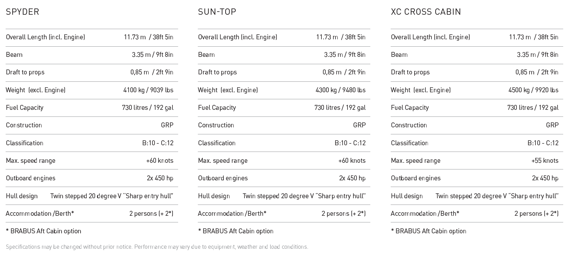

More about the BRABUS Shadow 900 range

A stunning flagship of the BRABUS Shadow fleet and a pinnacle achievement in the luxury sports-boat sector. The BRABUS Shadow 900 range, comprising Spyder, Sun-Top and XC Cross Cabin versions, is painstakingly hand crafted to the highest possible standards, combining great love for detail, bespoke engineering and innovative technologies.

This determined line of power cruisers ensures an instant 1-Second Wow factor with its signature design cues and unmatched go-anywhere capabilities. The boats’ Mercury Marine's twin 450R Verado XL 4,6-liter V8 four-stroke engines have a combined 900 hp. Hence the use of 900 in the boats’ names and their unrelenting top speed of 60+ knots.

About BRABUS Marine

BRABUS Marine is the cutting-edge alliance between two of the most renowned companies in their respective genres. Bringing together the award-winning Finnish boat builder Axopar Boats and the long-established, high-performance luxury automotive car producer BRABUS, to redefine luxury day boating through ultra-exclusive and exciting powerboats.

BRABUS Marine specializes in luxury products for global markets and is driven to become one of the world’s most iconic boat brands.

https://www.brabus.com/en/boats/brabusmarine.html

Media contacts for more information on this release:

Ms Marit Holmlund-Sund
Head of Brand & Marketing
Axopar Boats Oy
Mobile: +358 (0)40 538 3519
marit.holmlund-sund@axopar.com

Adam Fiander or Mike Wills
Broad Reach Communications Ltd
adam@broadreachcomms.co.uk /+44 (0)7703 598903
mike@broadreachcomms.co.uk / +44 (0)7884 075439

